2018 Zaker’s Book Picks

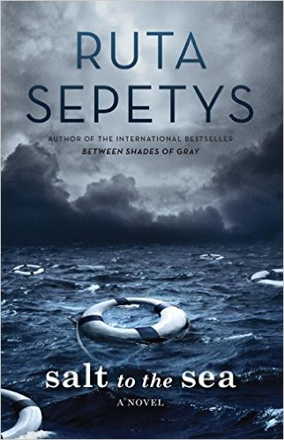

- I liked this novel so much that I immediately read Out of the Easy (in reference to “The Big Easy” —New Orleans — and Between Shades of Gray, both are novels by the same author. (This novel has no correlation with another series by a different author.) Between Shades of Gray also deals with Lithuania and WWII, and a Russian gulag work camp. If you want a different perspective on World War II, Salt to the Sea explores Lithuania, and the tests of survival that the people face from both Germany and Russia: historical fiction and unforgettable.

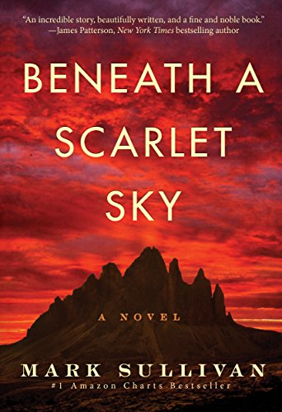

2. Also a historical novel, this book involves an Italian teen who is caught up in WWII, much like his small town, and shows what a difference one person can make in saving lives. This book is based on a true story of a forgotten hero, Pino Lella, and is being made into a movie as I write this. I hope that you will be as inspired by his courage and strength under pressure as I was.

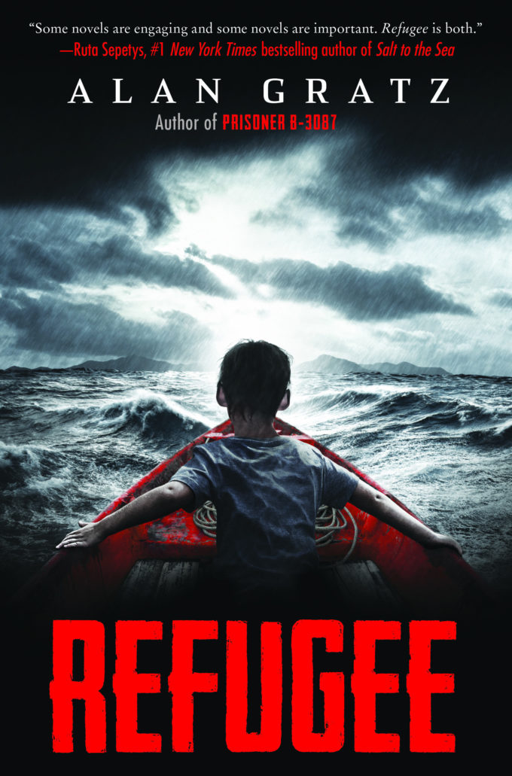

3. Gratz wrote Prisoner -B3087, and I will be reading that this summer. Refugee connects three stories from different decades together, as the protagonists flee from Syria , Cuba, and Nazi Germany. Three of my students (sophomores) read this book after me, and all three said it was a really good read. Thought-provoking and timely.

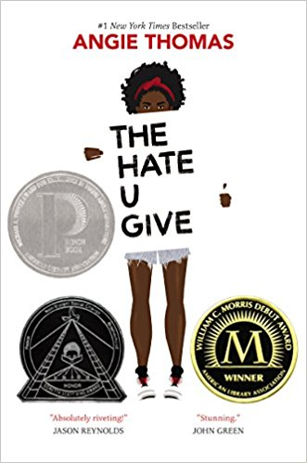

4. This novel is gritty, and explores a fictional story of an African American teenage girl who attends a mostly white high school, she discovers that she wears a “mask” at school, and doesn’t quite fit in with her urban neighborhood, where she is seen as an outsider because she doesn’t attend the local school. Incidentally, there is violence, anger, and a call for social justice in this book. This book made me stop and think often, and I hope that you will, too.

