2019 Mrs. Zaker’s Book Selections
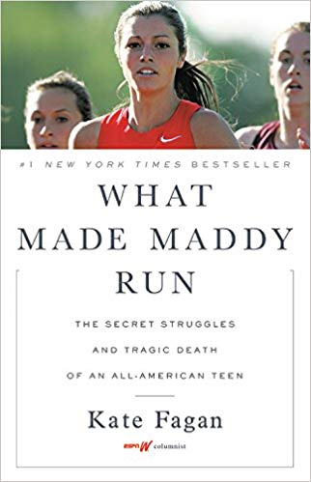
True story: Watch the ESPN clip that explains it.

http://www.espn.com/espnw/video/19768016/what-made-maddy-run

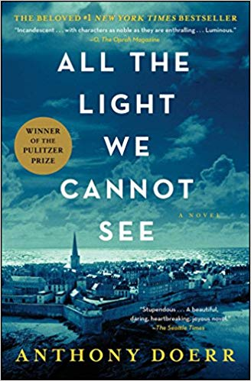
This book made many references to the Jules Verne novel below it; I had to read the classic next, because I didn’t understand all of the allusions to it.
Book trailer:
https://www.youtube.com/watch?v=W-LqfHA5BzQ

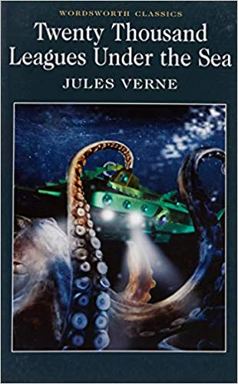

Here is a clip from the 1954 movie version starring Kirk Douglas:
https://www.youtube.com/watch?v=D3EzleL5DOs

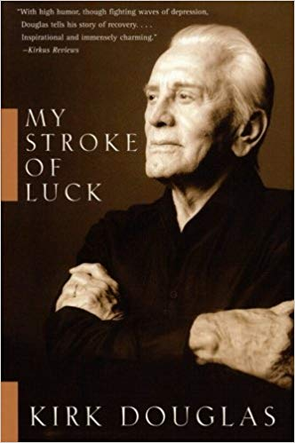
Here is the same actor who starred in the film above had a stroke later in life. Here is his autobiography.
https://www.theguardian.com/film/2017/feb/12/kirk-douglas-i-never-thought-id-live-to-100-thats-shocked-me
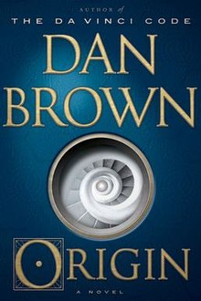
Since I loved several of his other books, I had to read Brown’s new read. I really enjoy how he ties art into his plots. In this case, it was modern art.
Here is the book trailer:
https://www.youtube.com/watch?v=XPoVknW-sig

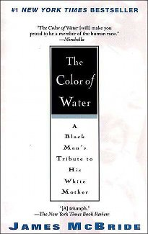
The more that I learn about race, I realize that I have so much more to learn. Book trailer: https://www.youtube.com/watch?v=FVidDYJ60lk

