One-Pager Assessment

Instructions: To show your understanding of the novel, you will be creating a “one-pager” that displays your thoughts, quotes, and examples from the text. This can address one of the many themes and questions, such as identity, prejudice, individuality, independent thinking, etc. Below is an example of one from The Outsiders.

A One Pager is a single-page response that shows your understanding of a piece of text you have read, be it a poem, novel, chapter of a book, or any other literature. It is a way of making representation of your individual, unique understanding. It is a way to be creative and experimental; it is a way to respond to your reading imaginatively and honestly. The purpose of a One Pager is to own what you are reading since we read differently when we know we are going to do something with the text that we have read. We learn best when we are able to create our own patterns!

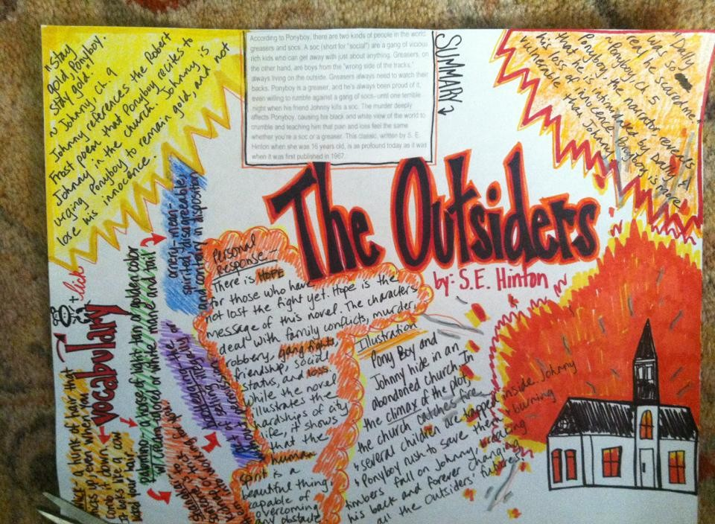

The Rules- What to include:
- Required: Be sure to put the title of the text you’re responding to somewhere on the page where the reader will notice it
- Required: Start with a border that reflects the theme. (This can include words, pictures, symbols, or even quotes)
- Required: Using text as a starting point, write your reactions or connections with the book. Be sure to include your analysis and AT LEAST ONE quote. Remember, you must cite your quote with the page number, and explain its relevance. Write them down anywhere on your page. Use different colors and/or writing styles to individualize each “quote” or phrase.
- Required: Draw a visual image. This could be a character, or a moment from a scene. You may also choose to draw symbols that convey an idea about the book.

More to add:
Also, choose all or a few of the following activities. It’s up to you!
Use a lot of color and patterns (perhaps even texture!) to illustrate your thoughts and ideas clearly and creatively.
- Make a personal statement about what you have read--what did it mean to you personally? What is your opinion, final thought, big question or personal connection?
- Ask a question or two and answer it.
- Create it in such a way that your audience will understand something about the literature from your One Pager
-Write a poem about a character or the theme. If this is particularly challenging you may choose to compose an acrostic poem.
-Personally connect to the book with an "I believe" Statement. This could be anything you believe after you have completed the unit.
-Create and Answer two questions about the book. Try to create and evaluate rather than remember and understand.
-Be colorful and neat. Your entire page should be filled with these elements. If you have more room, you may choose to repeat any of the previous. No space should be left blank, and nothing should be left in pencil.

What Not To Do:
• Don’t merely summarize--you’re not retelling the story.
• Use unlined paper only, to keep from being restricted by lines.
• Don’t think half a page will do-make it rich with “quotes” and images. FILL THE PAPER UP!

