Books I have Read in 2018- Ms. Cunningham

Wild by Cheryl Strayed

This is a memoir about hiking through the Pacific Coast Trail alone.
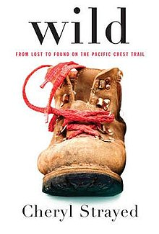
The Glass Castle by Jeannette Walls

This is a memoir about a girl and the abuse and neglect she faced when she grew up in squalor. She was able to rise above all that once she graduated high school and moved to New York City to pursue her passion.
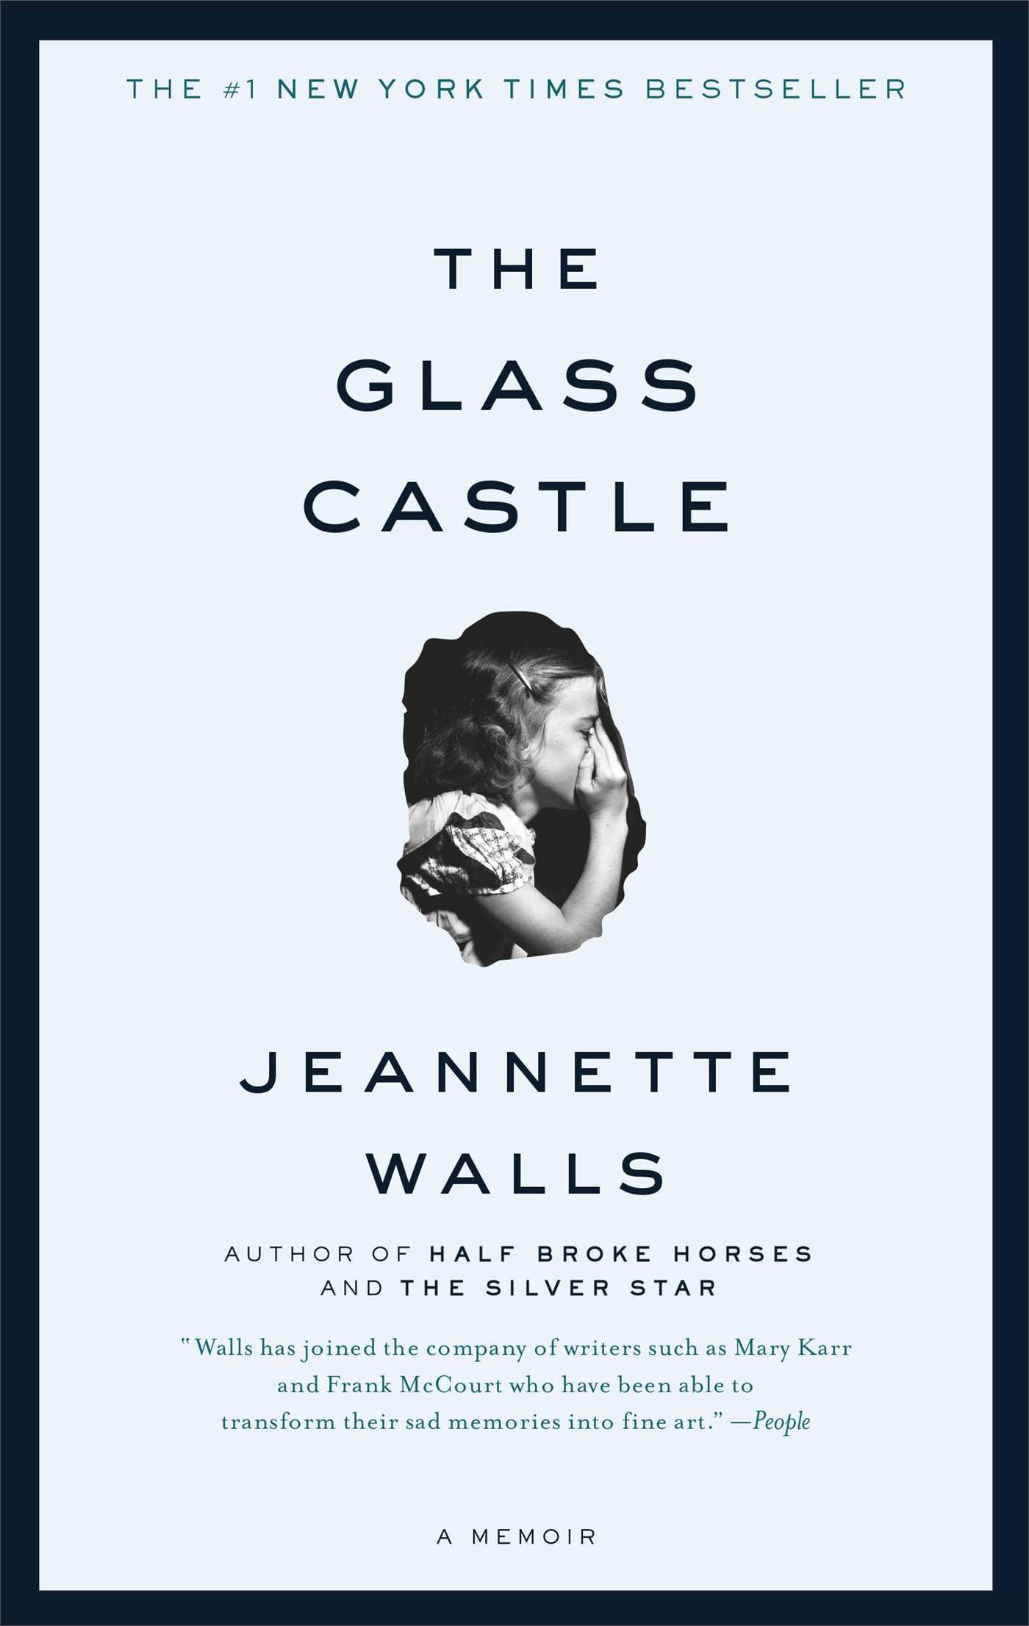

Running with Scissors by Augusten Burroughs

This is a memoir about a young boy and how he grew up in less than ideal circumstances.
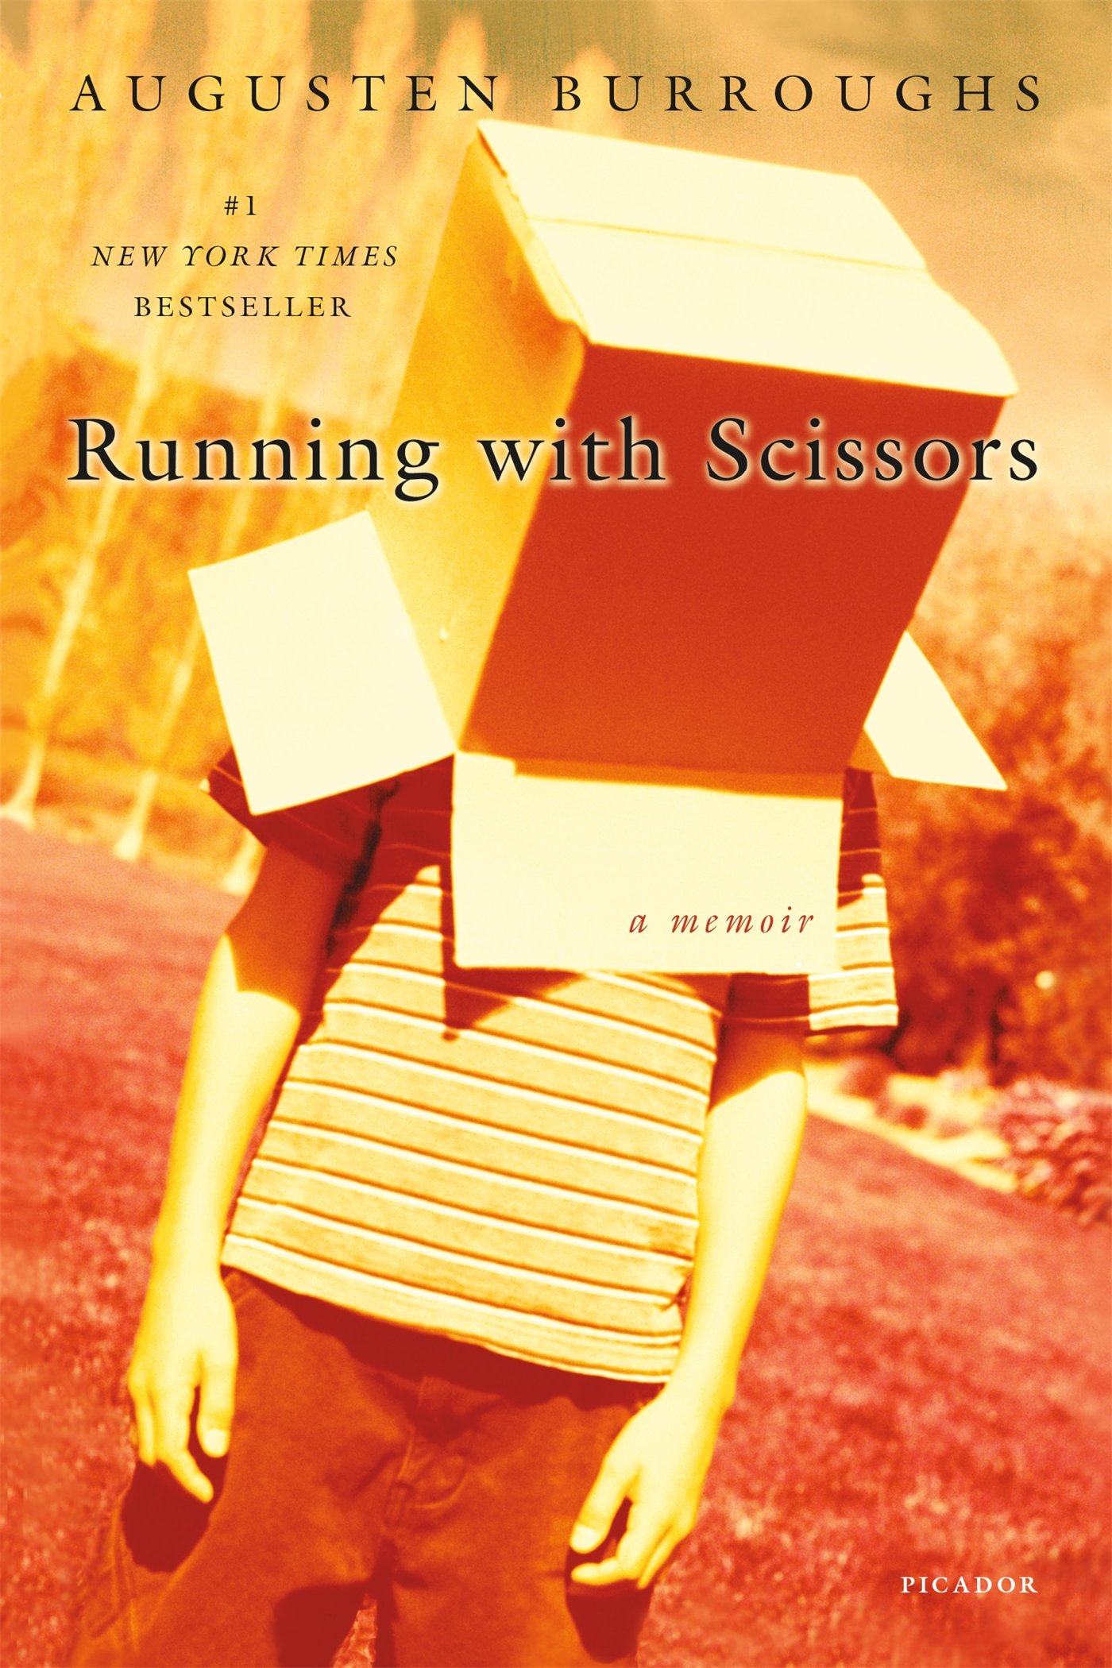

Dry by Augusten Burroughs

This is a memoir about his adult life- in rehab and the bad choices he made growing up and into adulthood.
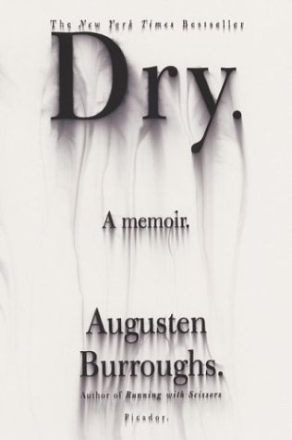

The Kite Runner by Khaled Hosseini

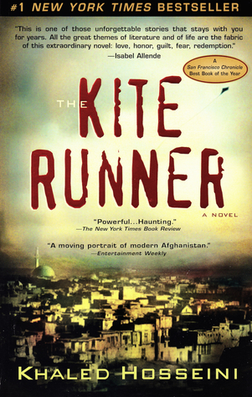
This is a memoir about a young boy growing up in Kabul and his living situation during his childhood.

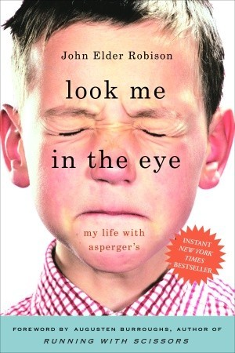
Future 2018 Reads

Look Me in the Eye: My Life with Asperger’s by John Robison

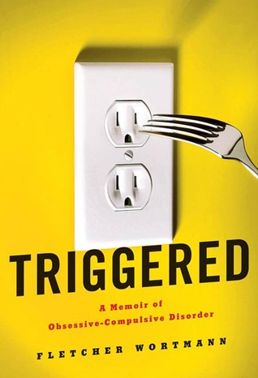
Triggered: A Memoir of Obsessive Compulsive Disorder

